Audio-Visual Entrainment: History and Physiological Mechanisms
David Siever¹, Edmonton, Alberta, Canada

Abstract: Since the discovery of photic driving by Adrian and Matthews in 1934, much has been discovered about the benefits of brain-wave entrainment (BWE) or audio-visual entrainment (AVE) as it is commonly known today. Studies are now available on the effectiveness of AVE in promoting relaxation, hypnotic induction and restoring somatic homeostasis, plus improving cognition, and for treating ADD, PMS, SAD, migraine headache, chronic pain, anxiety, depression and hypertension.

History

Clinical reports of flicker stimulation appear as far back as the dawn of modern medicine. It was at the turn of the 20th century when Pierre Janet, at the Salpêtrière Hospital in France, reported that when he had his patients gaze into the flickering light produced from a spinning spoked wheel in front of a kerosene lantern, it lowered their depression, tension and hysteria (Pieron, 1982). Then, in 1934, Adrian and Matthews published their results showing that the alpha rhythm could be "driven" above and below the natural frequency with photic stimulation (Adrian & Matthews, 1934).

This discovery further propagated dozens of small physiological outcome studies on the “flicker following response” by many well respected researchers (Bartley, 1934, 1937; Durup & Fessard, 1935; Jasper, 1936; Goldman, Segal, & Segalis, 1938; Jung, 1939; Toman, 1941). However no one considered the subjective and behavioral effects of photic stimulation. Finally in 1956, W. Gray Walter published the results on thousands of test subjects comparing flicker stimulation with the subjective emotional feelings it produced (Walter, 1956).

Meanwhile, William Kroger accomplished other important developments in photic stimulation. Kroger was a physician investigating why radar operators were going into trances in front of their radar sets and of course, leaving the ship or plane at great risk to the enemy. He concluded that the rhythmic “blip” of the radar was “pulling” the radar operators into a trance state. These findings compelled Kroger to team up with Sydney Schneider of the Schneider Instrument Company of Ohio to construct and market the first electronic clinical photic stimulator, called the “Brainwave Synchronizer.” It comprised of an intense xenon strobe light complete with a rotating dial that could be set to the frequencies of the standard four brain wave rhythms. They found the Brainwave Synchronizer had powerful hypnotic qualities and soon published a study on hypnotic induction (Kroger & Schneider, 1959). They also prompted other studies involving hypnotic induction in surgery and dentistry, and studies of general interest to the hypnosis profession (Sadove, 1963; Margolis, 1966; Lewerenz, 1963).

In 1981, my wife, Nancy, and I incorporated Comptronic Devices Limited, with a focus on designing TENS units and EMG feedback devices for dental (TMJ) applications. In 1984, I designed the “Digital Audio-Visual Integration Device” (DAVID1), used for hypnotic induction and to calm anxiety in performing arts students at the University of Alberta. The "light and sound" (L&S) market at this time was in its infancy and resided primarily within the new age sector. There was little “known” research to support L&S technology, and professionals by and large showed disinterest. Due mainly to poorly designed L&S products and a lack of research, about 40 L&S companies have come and gone, most of them during the 1980s and 1990s. However, since the time of Adrian and Matthews, a considerable number of studies have verified photic and auditory "driving" of the EEG. I have since re-named this phenomenon as “audio-visual entrainment” or AVE, as any given frequency of stimulation that is reflected in brain wave activity and observable on an EEG or QEEG can be entrained. Many more studies on photic or combined audio/photic stimulation exist than pure audio stimulation studies, however audio-only stimulation studies have confirmed audio entrainment (Chatrian, Petersen, & Lazarte, 1959) and its effect on calming masseter muscle tension (Manns, Miralles, & Adrian, 1981).

Physiology of Audio-Visual Entrainment

In order for entrainment to occur, a constant, repetitive stimuli of sufficient strength to "excite" the thalamus must be present. The thalamus then passes the stimuli onto the sensory-motor strip, the cortex in general and associated processing areas such as the visual and auditory cortexes. Figure 1 shows the visual pathway with the retina of both eyes becoming excited and sending pulses down the optic nerve, through the optic chiasm, and into the lateral geniculate of both thalami. From here, the visual signals are passed onto the visual and cerebral cortexes for further processing. Notice that there is very little delay from the onset of the flash to the response in the optic nerve, but a delay of approximately 100 msec occurs by the time the visual evoked potential (VEP) is elicited in the visual cortex. This delay may be why entrainment occurs best at the natural alpha frequency -- as 100 msec equates to 10 Hz.

Figure 1. The EEG Photic Stimulation Path

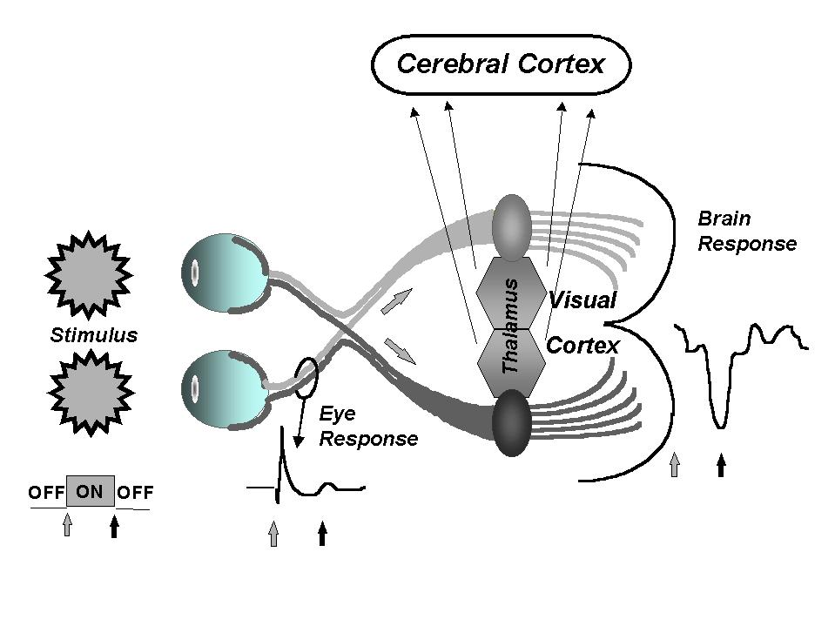

Photic entrainment begins its process as a series of overlapping evoked potentials (Kinney, McKay, Mensche, & Luria, 1973). Kinney broke down a simple VEP into its various components (Figure 2) representing the passage of time for 4, 8, 12 and 20 Hz. As can be seen, much of the VEP occurs within 250 msec, correlating to four Hz. The various overlapping parts were then vector summed into the mathematical VEP and compared with the actual VEPs observed by EEG at the higher, entrained frequencies, shown in Figure 2.

Figure 2. EEG Wavelet
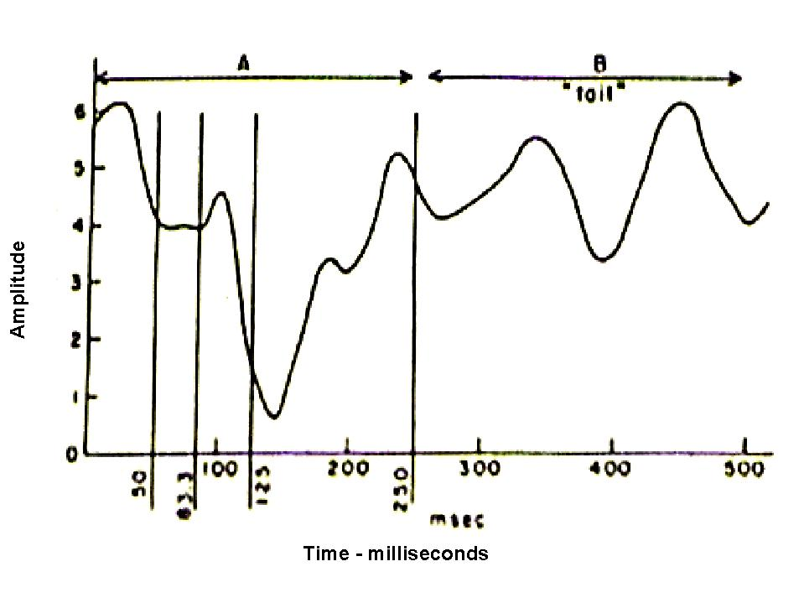

When this mathematical model was compared with the actual observed EEG of the entrained stimuli (Figure 3), a high degree of predictability was observed, demonstrating that photic entrainment is indeed a vector summation of VEPs and not a novel neuronal process.

Figure 3. EEG VEPs - Vector Addition (theoretical) Model vs Observed EEG
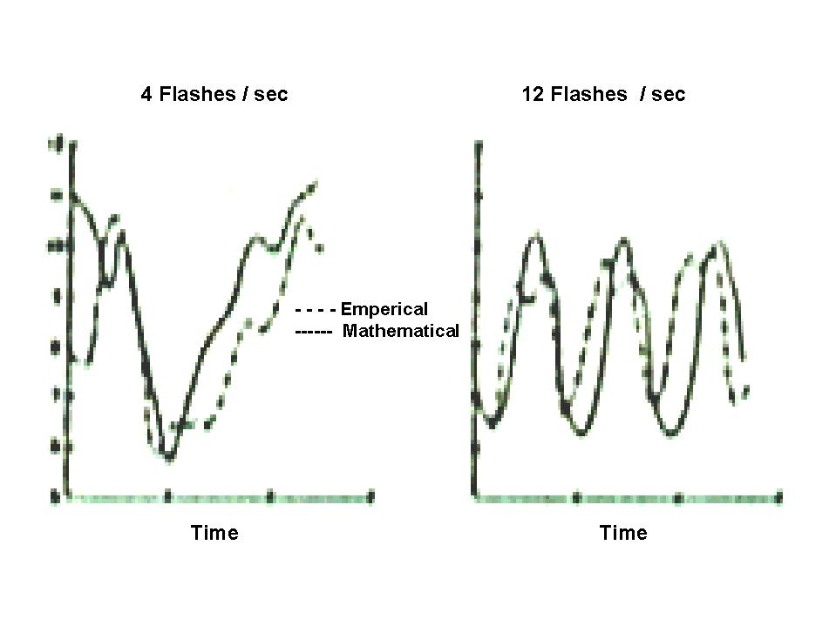
By definition, entrainment occurs when an EEG reflects the brain wave frequency duplicating that of the stimuli, be it audio, visual or tactile (Siever, 2002). Entrainment occurs best near one’s own natural alpha frequency (Toman, 1941; Kinney et al., 1973). LEDs and xenon strobe lights contain much harmonic content due to the "squareness" or rapid turn-on and turn-off transitions of the stimuli and these harmonics are reflected within the EEG. Figure 4 shows a strong and pure entrainment at 12 Hz. The harmonics (small wavelets) seen in the EEG are a reflection of the actual harmonics contained within the stimulus. Square wave stimulation is associated with an increased risk of seizure (Joyce & Siever, 2000; Ruuskanen-Uoti, 1994). The only way to produce entrainment without harmonics is via sine wave stimulation in which the stimuli turn on and turn off in slow, gentle transitions and do not contain harmonics. (Van der Tweel, 1965; Townsend, 1973; Regan, 1966; Siever, 2002).
Figure 4. EEG Showing Photic Entrainment

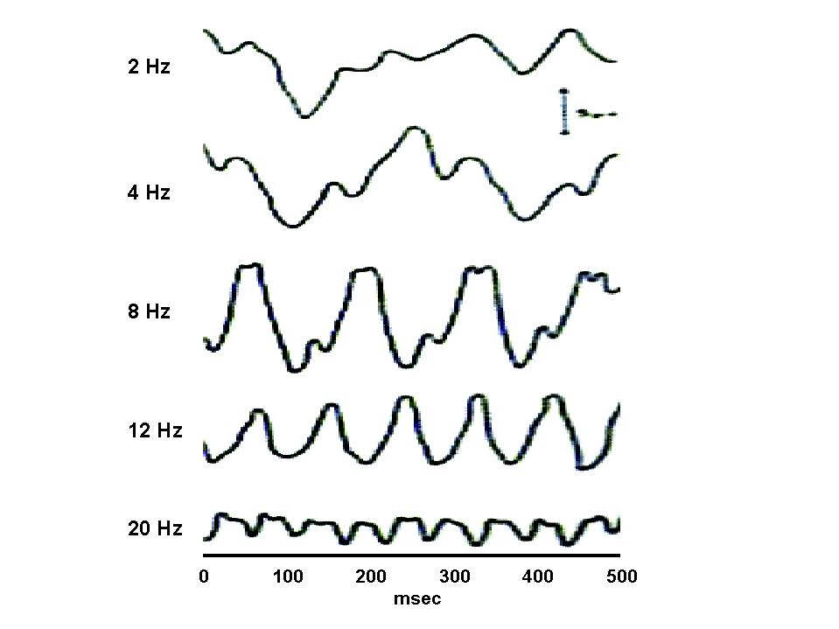

AVE at 18.5 Hz has also been shown to produce dramatic increases in EEG amplitude at the vertex (Frederick, Lubar, Rasey, Brim, & Blackburn, 1999), where it was found that:

- eyes-closed 18.5 Hz. photic entrainment increased 18.5 Hz EEG activity by 49%.
- eyes-open auditory entrainment produced increased 18.5 Hz. EEG activity by 27%.
- eyes-closed auditory entrainment produced increased 18.5 Hz EEG activity by 21%.
- eyes-closed AVE produced increased 18.5 Hz. EEG activity by 38.3%.

Entrainment primarily shows itself frontally and near the vertex (Siever, 2002). Figure 5 is a QEEG, or "brainmap" from the SKIL (Sterman-Kaiser Imaging Labs) database, in 1Hz bins showing the frequency distribution of AVE at 7.8 Hz. The area within the circle at 8Hz shows maximal effects of AVE in central, frontal and parietal regions (at 10uv in this case) as referenced with the oval area on the legend. It is through these effects that AVE has proven effective in treating depression, anxiety and attentional disorders. A harmonic is also present at 16 Hz. (the circled image), which is typical of semi-sine wave (part sine/part square wave) stimulation.

Figure 5. Brain Map in 1Hz Bins -- During 7.8 Hz AVE (SKIL-Eyes Closed)
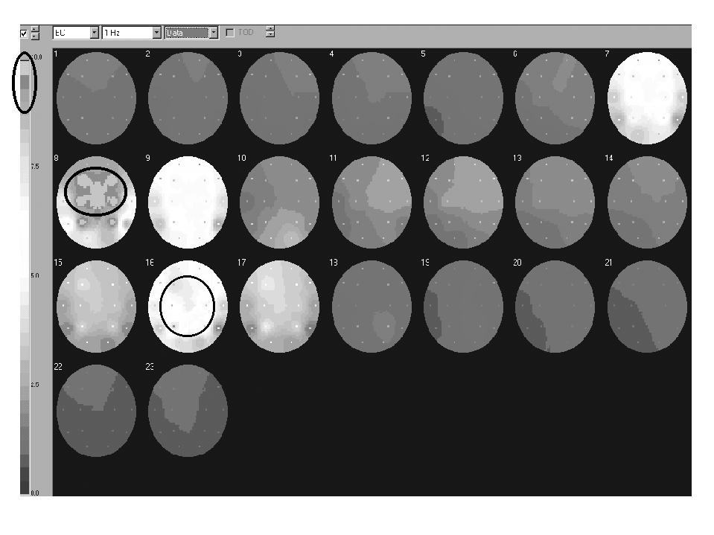

Body/Mind Effects of Audio-Visual Entrainment

We conceptualize AVE as achieving its effects through several mechanisms at once (Siever, 2000). These include:

- dissociation / hypnotic induction,
- increased neurotransmitters,
- possible increased dendritic growth,
- altered cerebral blood flow, and
- normalized EEG activity.

Dissociation

Dissociation is described as a process where feelings, memories and physical sensations are kept apart from other information that would normally be logically associated. In pathological terms, dissociation is a maladaptive disruption in integrated functioning typically associated with depersonalization, stress, identity, amnesia and depersonalization disorders (Brownbeck & Mason, 1999).

On the other hand, dissociation occurs when we meditate, exercise, read a good book, take in a movie or enjoy a sporting event, because we get drawn into the present moment and dissociate from all of our daily hassles, worries, anxieties and the resulting unhealthy mental chatter. Several techniques such as dot staring and stimulus depression have been shown to induce dissociation (Leonard, Telch, & Harrington, 1999). Audio dissociation analgesia using white noise has been shown to effectively increase pain threshold and pain tolerance during a dental procedure (Morosko & Simmons, 1966).

Regardless of the activity, this type of dissociation reduces our weekly stress load, whether we are aware of it or not. In essence, when we focus on something, we dissociate from other things. The saying, “a change is as good as a rest,” has much more truth to it than initially meets the eye (Siever, 2000).

The first study on dissociation induced via entrainment involved hypnotic induction and found that photic stimulation at alpha frequencies could easily put subjects into hypnotic trances (Kroger & Schneider, 1959; Lewerenz, 1963). Figure 6 shows the results of Kroger and Schneider's study in which nearly 80% of the participants in the study were in a hypnotic trance within six minutes of photic entrainment.

Figure 6. Photic Stimulation Induction of Hypnotic Trance (Kroger & Schneider, 1959)

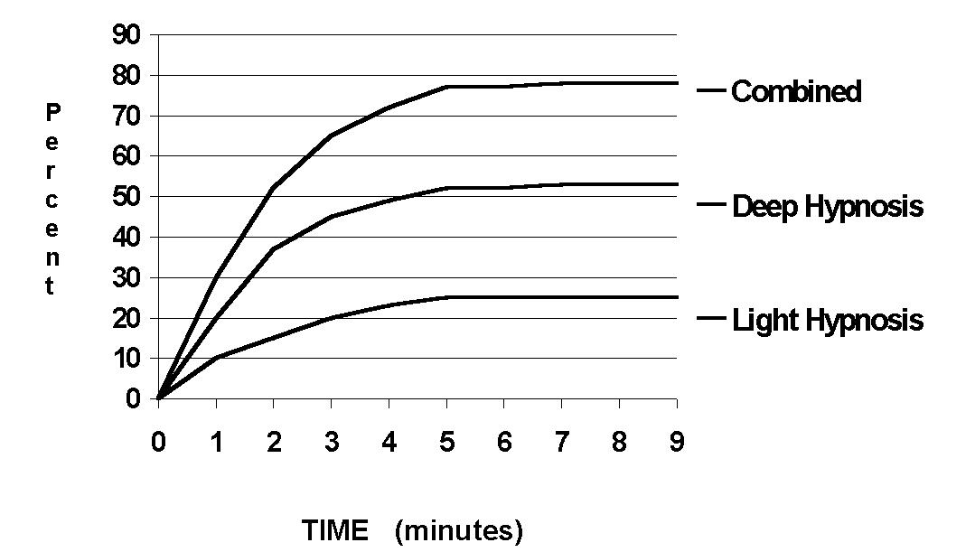

Psychologists have been looking for ways to dissociate their clients as a part of fear and phobia treatment. Inducing dissociation using AVE delivered by the DAVID1 was found to be more effective than dot staring or stimulus deprivation (Leonard, Telch, & Harrington, 1999) as shown in Figure 7.

Figure 7. AVE Induced Dissociation (Leonard, et al., 1999)
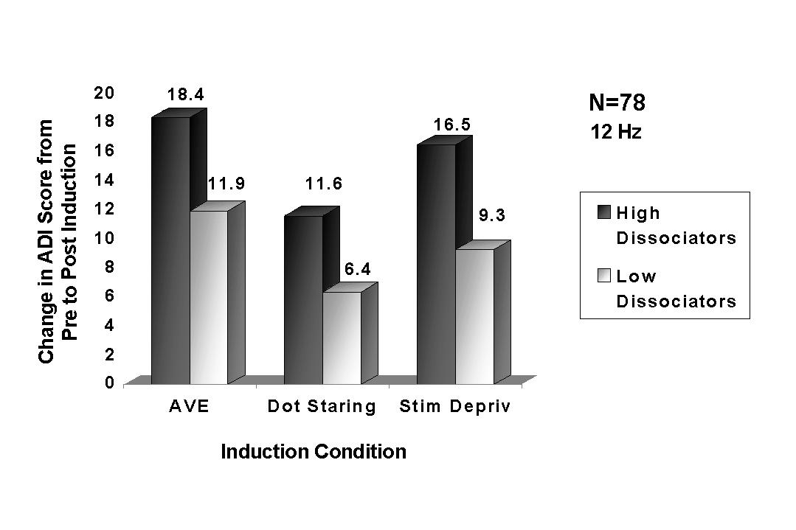

Furthermore, Leonard completed a second study with people who experience dissociative anxiety (Leonard, Telch & Harrington, 2000). People with dissociative anxiety feel a need to have a sense of control in their lives and become anxious or panicky when they dissociate, be it driving home, at the office, or in a clinical setting. The Acute Dissociation Inventory (ADI) is a 35-item self-report scale (Leonard, et.al., 1999). It assesses dissociative sensations (ADI-Dissoc) and subjective anxiety, or dissociative anxiety in response to dissociative provocation (ADI-Anx). Leonard and her colleagues clinically dissociated people who become anxious when dissociating, by using a DAVID Paradise HemistepTM alpha session. As expected, the participants’ anxiety (ADI-Anx) had almost doubled by the end of the AVE session. The surprise, however, was that their heart rate actually decreased, contrary to normal anxiety reactions (Figure 8). With the ability to clinically dissociate these people, yet simultaneously calm them down somatically, AVE can be used as a desensitization tool for reducing dissociative anxiety.

Figure 8. Dissociative Anxiety and Somatic Arousal (Leonard, et al., 2000)
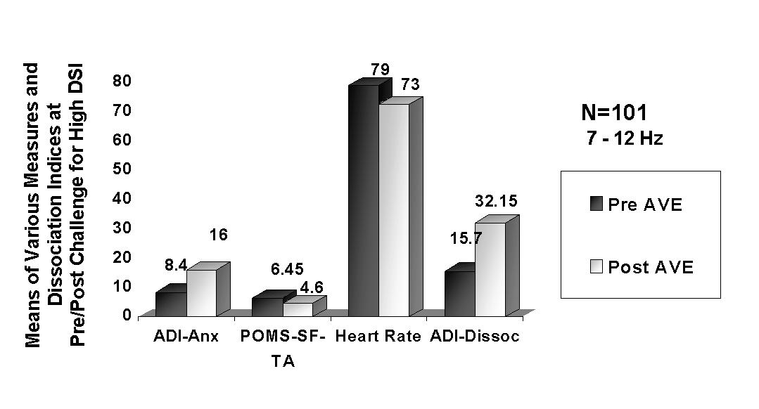
A dissociative mindstate or hypnotic trance may be described in terms of an altered state of consciousness (ASC) in which the subject (or an independent observer of the subject) observes a qualitative shift in the normal pattern of mental functioning (Glicksohn, 1986-87). ASCs produced via overstimulation also occur when a person is bombarded with higher than normal levels of sensory input, usually in more than one sensory modality (Hear, 1971, Lipowsky, 1975, Goldberger, 1982). Glicksohn studied photic entrainment and the ASCs produced. He monitored the EEGs of subjects during photic entrainment. They all described a wide variety of reactions to the stimulation with some reporting incredible imagery consisting of items they had seen before in their lives, intertwined with geometrical patterns while others reported no visual changes at all. At the end of the study, Glicksohn concluded that:

1) It is the increase in alpha activity created by photic driving, and not the natural alpha activity itself, that is conducive to an ASC.
2) The appearance of visual imagery is neither necessary nor all that is involved to indicate the experience of an ASC.
3) If a photic driving response is not elicited, the subject will not experience an ASC.

Glicksohn's observations support the concept that in order for AVE to occur, the stimulating frequency must have a direct impact on brain wave frequency and be observable on an EEG.
Dissociation and Restabilization

Dissociating clients with trauma histories, during the course of treatment is important. The state of mind that a person has at any given moment is made up of the brainwave activity associated with apprehension, anxiety, physical tension (proprioceptive/afferent associations), destructive thoughts, and conditioned responses relating to the colors, smells, sounds, etc. Once the mind is clear, all of these tensions, conditioned responses (bracing habits), fearful thoughts and the effects of afferance (sensory information) subside, allowing the mind and brain to relax, become more malleable and open to new healthy thoughts, post-hypnotic suggestions, brainwave activity and so on. During AVE, the EMG and electro-dermal responses fall, finger temperature increases and breathing becomes smooth and diaphragmatic. These changes reflect a return to homeostasis or restabilization, hence the term dissociation and restabilization (DAR) (Siever, 2000).

Figure 9 shows a typical reduction in forearm EMG and Figure 10 shows a typical increase in finger temperature. Notice that restabilization begins after about six minutes of AVE, when the user begins dissociating. Figure 11 shows normalization of breathing and heart rate variability following exposure to AVE at 7.8 Hz.

Figure 9. Forearm EMG Levels During AVE (Hawes, 2000)

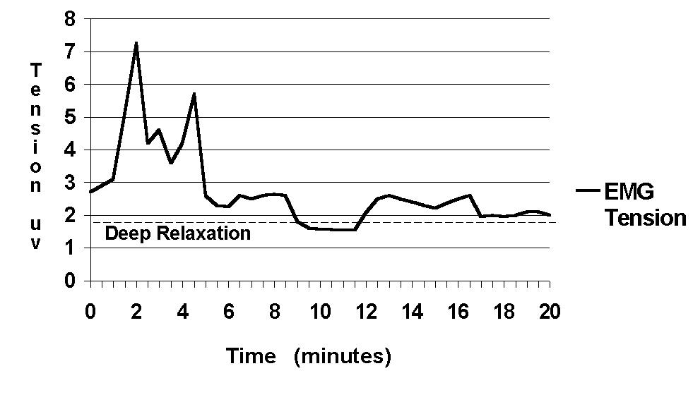
Figure 10. Peripheral Temperature Levels During AVE (Hawes, 2000)

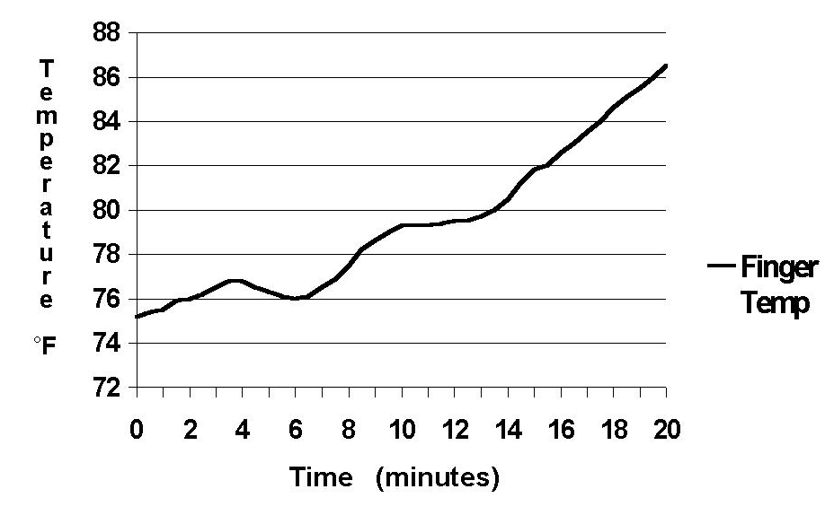
Neurotransmitters

There is evidence that blood serum levels of serotonin, endorphine, and melatonin rise considerably following 10 Hz., white-light AVE (Shealy, 1989). Increases in endorphines reflect increased relaxation while increased norepinephrine along with a reduction in daytime levels of melatonin, indicate increased alertness (Figure 11).

Figure 11. Neurotransmitter Levels Following AVE (Shealy, 1989)

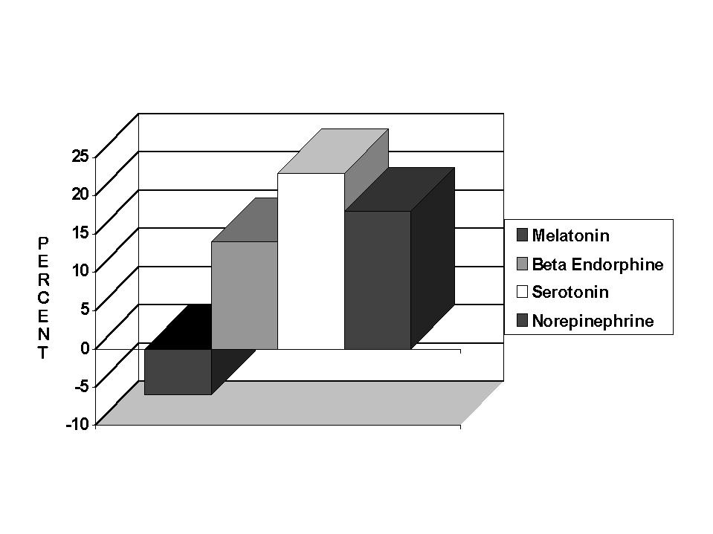

Dendritic Growth

There is evidence that stimulating neurons with mild electrical stimulation promotes growth of dendrites and dendritic shaft synapses in the cells being stimulated (Beardsley, 1999; Lee, Schottler, Oliver, & Lynch, 1980). However, studies do not yet exist on the influence of AVE on dendritic growth, although it is suspected because many people with autism, palsy, stroke and aneurysm (Russell, 1996) have gained significant motor and cognitive function following a treatment program of AVE.

Cerebral Blood Flow

Cerebral blood flow (CBF) is essential for good mental health and function. SPECT and FMRI imaging of CBF show that hypoperfusion of CBF is associated with many forms of mental disorders. CBF increases dramatically during AVE (Fox & Raichle, 1985; Sappy-Marinier et al., 1992). Figure 18 shows an increase of 28% in cerebral blood flow within the striate cortex, a primary visual processing area within the occiput. As an interesting note, maximal CBF occurs at 7.8 Hz, the Schumann Resonance of the earth.
Figure 12. Cerebral Blood Flow at Various AVE Repetition Rates (Fox & Raichle, 1985)
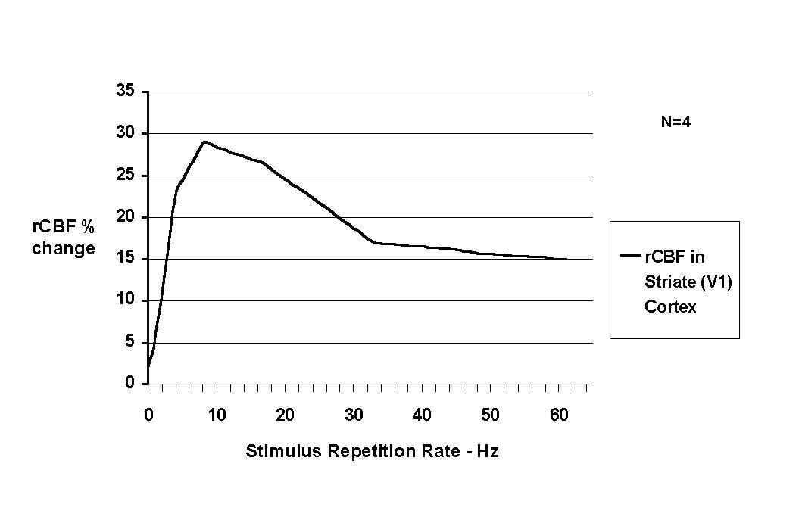
Following Fox and Raichle’s study was a whole head PET analysis of visual entrainment at 0, 1, 2, 4, 7, and14 Hz (Mentis, et. al., 1997). This study on 19 healthy, elderly (mean age=64 years) subjects found that regional cerebral blood flow (rCBF) was activated differentially with the:

1) left anterior cingulate showing maximal increases in rCBF at 4 Hz.
2) right anterior cingulate showing decreases in rCBF with frequency.
3) left middle temporal gyrus showing increases in rCFB at 1 Hz.
4) striate cortex showing maximal rCBF at 7 Hz.
5) lateral and inferior visual association areas showing increases in rCBF with frequency.

While there may be benefits to increasing occipital CBF, there is even greater concern regarding conditions involving hypoperfuson of CBF in frontal regions. Frontal disorders include: anxiety, depression, attentional and behavior disorders, and impaired cognitive function (Amen, 1998). Figure 13 shows an increase in frontal CBF recorded on Hershel Toomin’s “Thinking Cap” (or “Hemoencephalogram”) using infra-red light to measure perfusion of CBF. Notice that CBF at FPZ increases by 15% in 10 minutes (Toomin, personal communication).

Figure 13 Hemoencephalographic Measure of Cerebral Blood Flow During 10 Hz AVE

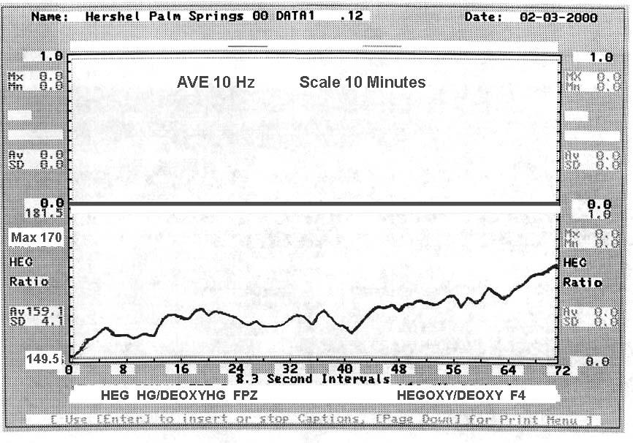

Normalized EEG Activity

Figure 14 shows a fairly typical brain map in 1 Hz bins of a person with mild depression and anxiety as shown on the Skil database. Notice that alpha is slowed and approaching +2SD from the norm and that some beta frequencies (16-18 Hz) are high (>1SD) in central frontal areas.

Figure 14. Brain Map in 1 Hz Bins of Individual with Depression and Anxiety (SKIL-Eyes Open)
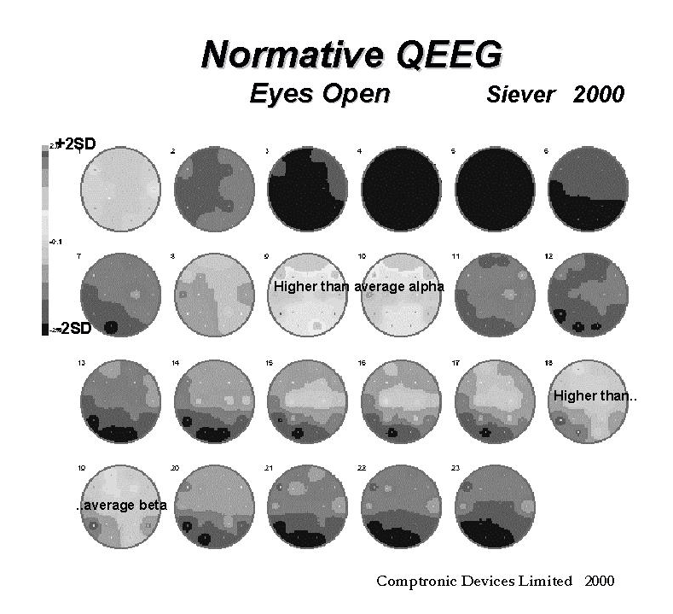

Following an AVE session of 7.8 Hz., both alpha and beta activity are normalized as shown below in Figure 15.

Figure 15. Brain Map Following 7.8 Hz AVE (SKIL-EO)
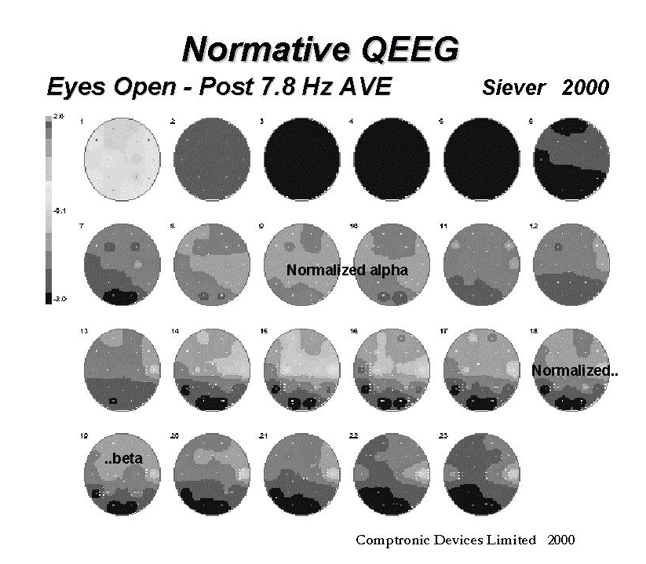

Conclusion

In closing, AVE has the ability to quickly and effectively relax people out of high sympathetic activation and traumatic states of mind, bringing a return to homeostasis. AVE may be used alongside hypnotic suggestions on tape/CD or live via a microphone. At the same time however, AVE exerts a powerful influence on brain/mind stabilization and normalization. At the end of an AVE session, the user may realize that he/she has not felt so relaxed for years -- perhaps not since childhood.

Footnote:

1. For more information, address all correspondence to:

David Siever, c/o Mind Alive Inc., 9008 - 51 Avenue, Edmonton, Alberta, Canada, T6E 5X4
Toll Free: (800) 661-6463 Fax: (780) 461-9551 Web: www.mindalive.com
Email: info@mindalive.com

References

Adrian, E. & Matthews, B. (1934) The Berger rhythm: Potential changes from the occipital lobes in man. Brain, 57, 355-384.

Amen, D. (1998). Change your brain, change your life. New York: Three Rivers Press.

Barlow, J. (1960). Rhythmic activity induced by photic stimulation in relation to intrinsic alpha activity of the brain in man. Electroencephalography and Clinical Neurophysiology, 12, 317-326.

Bartley, S. (1934). Relation of intensity and duration of brief retinal stimulation by light to the electrical response of the optic cortex of the rabbit. American Journal of Physiology, 108, 397-408.

Bartley, S. (1937). Some observations on the organization of the retinal response. American Journal of Physiology, 120, 184-189.

Beardsley, T. (1999, June). Getting wired. Scientific American, 24-25.

Brownbeck, T. & Mason, L. (1999). Neurotherapy in the treatment of dissociation. In J. R. Evans, & A. Arbanel. (Eds.), Introduction to quantitative EEG and neurofeedback (pp 145-156). San Diego: Academic Press.

Chatrian, G., Petersen, M. & Lazarte, J. (1959). Response to clicks from the human brain: Some depth electrographic observations. Electroencephalography and Clinical Neurophysiology, 12, 479-489.

Dempsey, E. & Morison, R. (1942). The interaction of certain spontaneous and induced cortical potentials. American Journal of Physiology, 135, 301-307.

Donker, D., Njio, L., Storm Van Leewan, W., & Wieneke, G. (1978). Interhemispheric Relationships of Responses to Sine Wave Modulated Light in Normal Subjects and Patients. Encephalography and Clinical Neurophysiology, 44, 479-489.

Durup, G. & Fessard, A. (1935). L'electroencephalogramme de l'homme (The human electroencephalogram). Annale Psychologie, 36, 1 –32.

Fox, P. & Raichle, M. (1985). Stimulus rate determines regional blood flow in striate cortex. Annals of Neurology, 17, (3), 303-305.

Fox, P., Raichle, M., Mintun, M., & Dence, C. (1988). Nonoxidative glucose consumption during focal physiologic neural activity. Science, 241, 462-464.

Frederick, J., Lubar, J., Rasey, H., Brim, S., & Blackburn, J. (1999). Effects of 18.5 Hz audiovisual stimulation on EEG amplitude at the vertex. Journal of Neurotherapy, 3 (3), 23-27.

Glista, M.D., Frank, M. D., & Tracy, M. D. (1983). Video games and seizures. Archives of Neurology, 40, 588.

Glicksohn, J. (1986-87). Photic driving and altered states of consciousness: An exploratory study. Imagination, Cognition and Personality, 6 (2), 1986-87.
Goldberger, L. (1982). Sensory deprivation and overload. Handbook of Stress, The Free Press, New York, 410-418.

Goldman, G., Segal, J., & Segalis, M. (1938). L'action d'une excitation inermittente sur le rythme de Berger. (The effects of intermittent excitation on the Berger rhythms (EEG rhythms). C.R. Societe de Biologie Paris, 127, 1217-1220.

Hear, J. (1971). Field dependency in relation to altered states of consciousness produced by sensory-overload. Perception and Motor Skills, 33, 192-194.

Jasper, H. H. (1936). Cortical excitatory state and synchronism in the control of bioelectric autonomous rhythms. Cold Spring Harbor Symposia in Quantitative Biology, 4, 32-338.

Joyce, M. & Siever, D. (2000). Audio-visual entrainment program as a treatment for behavior disorders in a school setting. Journal of Neurotherapy, 4 (2) 9-25.

Jung, R. (1939). Das Elektroencephalogram und seine klinische Anwendung.(The electroencephalogram and its clinical application). Nervenarzt, 12, 569-591.

Kinney, J. A., McKay, C., Mensch, A., & Luria, S. (1973). Visual evoked responses elicited by rapid stimulation. Encephalography and Clinical Neurophysiology, 34, 7-13.

Kroger, W. S. & Schneider, S. A. (1959). An electronic aid for hypnotic induction: A preliminary report. International Journal of Clinical and Experimental Hypnosis, 7, 93-98.

Lee, K., Schottler, F., Oliver, M., & Lynch, G. (1980). Brief bursts of high-frequency stimulation produce two types of structural change in rat hippocampus. Journal of Neurophysiology, 44 (2), 247-258.

Leonard, K., Telch, M., & Harrington, P. (1999). Dissociation in the laboratory: A comparison of strategies. Behaviour Research and Therapy, 37, 49-61.

Leonard, K., Telch, M., & Harrington, P. (2000). Fear response to dissociation challenge. Anxiety, Stress and Coping, 13, 355-369.

Lipowsky, Z. (1975). Sensory and information inputs over-load: behavioral effects. Comprehensive Psychiatry, 16, 199-221

Lewerenz, C. (1963). A factual report on the brain wave synchronizer. Hypnosis Quarterly, 6 (4), 23.

Manns, A., Miralles, R., & Adrian, H. (1981). The application of audiostimulation and electromyographic biofeedback to bruxism and myofascial pain-dysfunction syndrome. Oral Surgery, 52 (3), 247-252.

Margolis, B. (1966, June). A technique for rapidly inducing hypnosis. CAL (Certified Akers Laboratories), 21-24.

Mentis, M., Alexander, G., Grady, C., Krasuski, J., Pietrini, P., Strassburger, T., Hampel, H., Schapiro, M. & Rapoport, S. (1997). Frequency variation of a pattern-flash visual stimulus during PET differentially activates brain from striate through frontal cortex. Neuroimage, 5, 116-128.

Morosko, T. & Simmons, F., (1966). The effect of audio-analgesia on pain threshold and pain tolerance. Journal of Dental Research, Vol 45, 1608-1617.

Pieron, H. (1982). Melanges dedicated to Monsieur Pierre Janet. Acta Psychiatrica Belgica, 1, 7-112).

Regan, D. (1966). Some characteristics of average steady-state and transient responses evoked by modulated light. Electroencephalogy and Clinical Neurophysiology, 20, 238-248.

Russell, H. (1996). Entrainment combined with multimodal rehabilitation of a 43-year-old severely impaired postaneurysm patient. Biofeedback and Self Regulation, 21, 4.

Ruuskanen-Uoti, H. & Salmi, T. (1994, January). Epileptic seizure induced by a product marketed as a “Brainwave Synchronizer.” Neurology, 44, 180.

Sadove, M.S. (1963, July). Hypnosis in anaesthesiology. Illinois Medical Journal, 39-42.

Sappey-Marinier, D., Calabrese, G., Fein, G., Hugg, J., Biggins, C., & Weiner, M. (1992). Effect of photic stimulation on human visual cortex lactate and phosphates using 1H and 31P magnetic resonance spectroscopy. Journal of Cerebral Blood Flow and Metabolism, 12 (4), 584-592.

Siever, D. (2000). The rediscovery of audio-visual entrainment technology. Unpublished manuscript.

Siever, D. (2002). New technology for attention and learning. Unpublished manuscript.

Shealy, N., Cady, R., Cox, R., Liss, S., Clossen, W., & Veehoff, D. (1989). A comparison of depths of relaxation produced by various techniques and neurotransmitters produced by brainwave entrainment. Shealy and Forest Institute of Professional Psychology. A study done for Comprehensive Health Care, Unpublished.

Toman, J. (1941). Flicker potentials and the alpha rhythm in man. Journal of Neurophysiology, 4, 51-61.

Townsend, R. (1973). A device for generation and presentation of modulated light stimuli. Electroencephalography and Clinical Neurophysiology, 34, 97-99.

Van Der Tweel, L. & Lunel, H. (1965). Human visual responses to sinusoidally modulated light. Encephalography and Clinical Neurophysiology, 18, 587-598.

Walter, W. G. (1956). Color illusions and aberrations during stimulation by flickering light. Nature, 177, 710.

